# Soft ware design

## Part 1 User Inter face Design

**按钮区**

**识别结果区**

**状态显示**

**数据显示**

**摄像头数据区**

Software Interface

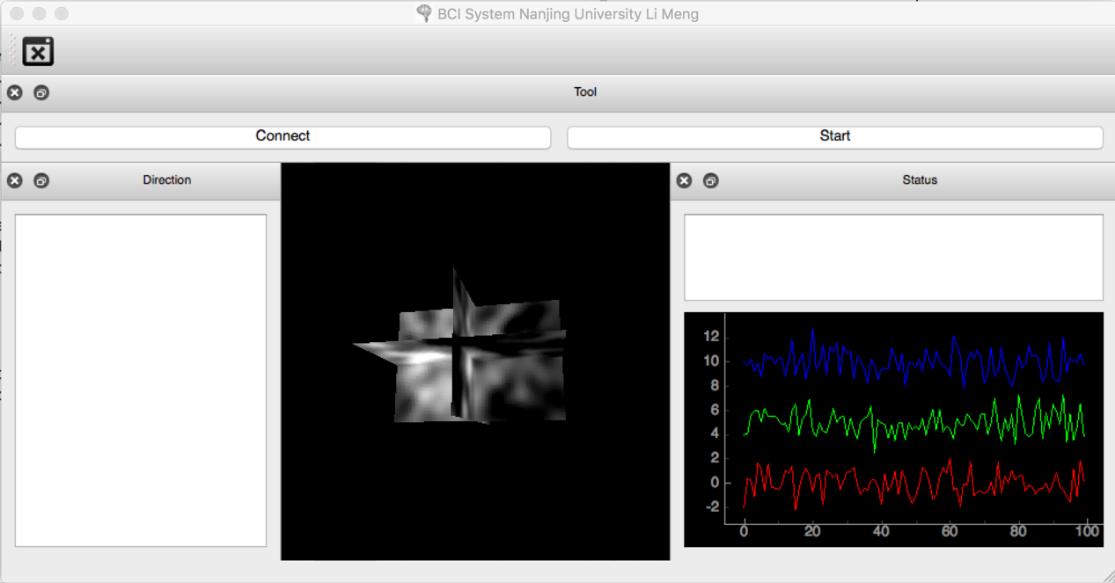

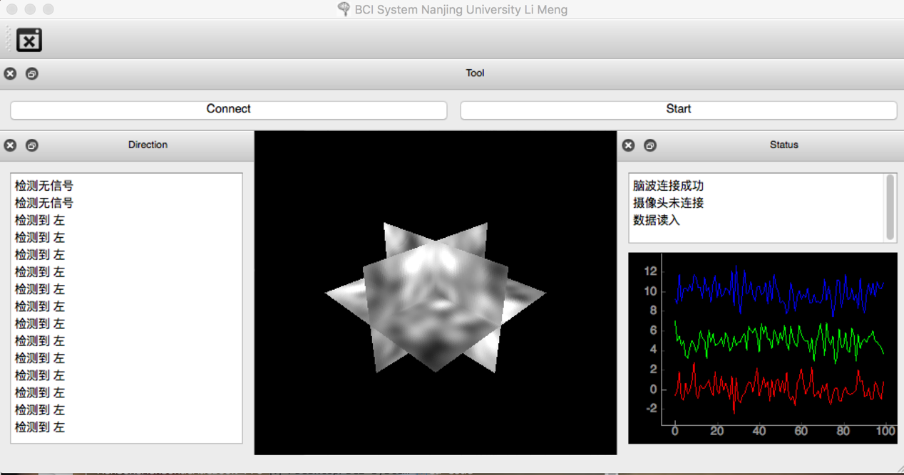Running status

# Code architecture(see the attached file)

|  |  |
| --- | --- |
| Module File | |
| Data cache | BciDatacache.py |
| User interface | BciUI.py |
| Classifier | Bciclassififer.py |
| Emotiv connecter | Emologger.py |
| Output Control | Bcicontrolcode.py |
| Preprocessor | Bcipreprocessor |
| Camera update | Unfinished |
| Robot car module | Unfinished |